AI-Driven Cybersecurity Risk Assessment: A Data Management and Visualization Report

Author: Priscilla Araba Hagan

I. EXECUTIVE SUMMARY

This report documents a comprehensive data-driven assessment of the global cybersecurity risk landscape, utilizing a Kaggle dataset spanning 2015–2024. The project successfully executed the full data lifecycle, from transforming the original raw data into a reliable Third Normal Form (3NF) relational structure to analyzing critical trends using a professional visualization platform.

The analysis focused on three core areas: financial exposure, multi-year incident trends, and the operational complexity of incident resolution.

Key Findings:

- Highest Financial Risk: The IT ($24,810M) and Banking ($22,772M) sectors face the highest cumulative financial risk, necessitating prioritized defensive resource allocation.
- Highest Operational Risk: Ransomware and SQL Injection attacks introduce the most unpredictable and longest resolution times, indicating significant operational complexity in recovery and system restoration.
- Concentration of Severity: The highest-ranking, most damaging incidents, as defined by a custom AI Risk Score model, are overwhelmingly concentrated in the United States, primarily driven by Ransomware and SQL Injection against critical infrastructure.

II. DATABASE DESIGN & NORMALIZATION

The project’s foundation involved transforming the original flat-file CSV dataset into a robust relational database structure, engineered to meet the Third Normal Form (3NF).

Normalization Rationale
The original dataset contained significant data redundancy (e.g., repeating the same "Attack Type" name multiple times across records). Normalization was essential to eliminate this redundancy, improve data integrity, and ensure the reliability of complex analytical queries.

Final 3NF Schema
The final design decomposed the single flat file into five primary tables connected via Primary Keys (PK) and Foreign Keys (FK):
- Lookup Tables (Dimensional): dbo.AttackType, dbo.Country, and dbo.Industry.
- Fact Tables (Operational): dbo.Incident (the main fact table) and dbo. Global_Cybersecurity_Threats_2015-2024 (the original source data table).

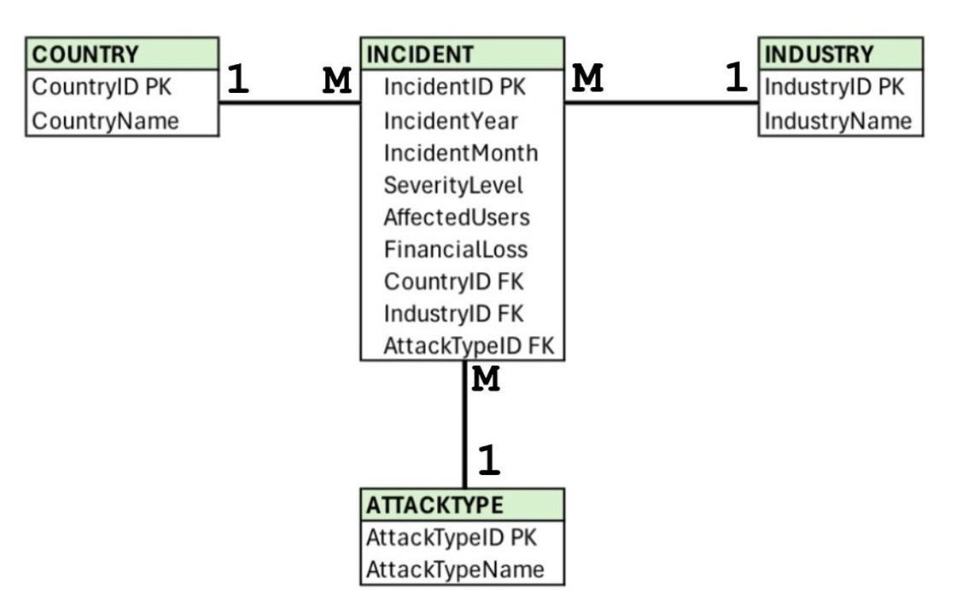

The complete database structure, including table definitions, Foreign Key constraints, and data loading commands, was successfully scripted into the Cybersecurity_Schema_3NF.sql file. This required careful assembly of the scripts in a dependency-aware order (lookup tables before the Incident fact table) to prevent Foreign Key constraint errors.

III. DATA TRANSFORMATION & TOOL UTILIZATION

Following database design, the data was prepared for visualization and utilized an LLM to accelerate the transformation process.

Data Validation
The data underwent validation to ensure integrity for analysis:
- Structuring: The raw CSV file was imported and structured to ensure correct columnar separation.
- Data Type Validation: All key analytical fields were reviewed to confirm correct data types, separating dimensions and numerical measures.

Reflection on AI Tooling
The project used a Large Language Model (LLM) as a code accelerator. This experience highlighted the common challenge of Environmental Blindness in AI tools: the LLM excelled at generating high-level SQL queries but failed to align the code with the live database server’s exact table and column naming conventions, necessitating manual troubleshooting.

IV. DATA VISUALIZATION & STRATEGIC ANALYSIS

The analysis addressed three core research questions using the cleaned and structured data, visualized in an interactive Tableau dashboard.

A. Attack Trends and Sector Targeting
- Threat Intensity: Incident volume remains consistently high, suggesting a stable, intense threat environment (around 300–320 incidents per year after 2017).

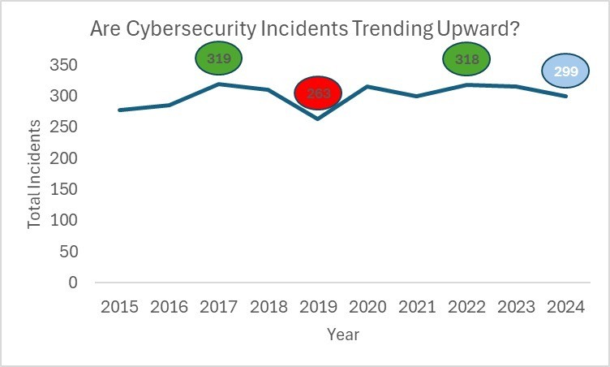

- Trend Volatility: Attack types exhibit high year-to-year volatility, suggesting a rapid "cyclical attack–defense dynamic."
- Targeting: The IT, Banking, and Government sectors are the most frequently targeted.

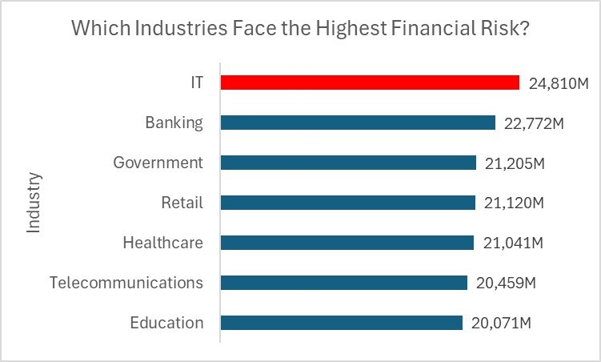

B. Financial Impact and AI Risk Scoring

Country | Attack Type | Industry/Name | Loss (Millions $) | Users  Affected | Risk  Score
USA | Ransomware | Telecommunications | $99.88 | 999,508 | 1099.38
USA | SQL Injection | Banking | $98.91 | 995,462 | 1094.37
USA | Ransomware | Government | $99.34 | 999,635 | 1092.98
Germany | DDoS | Education | $98.61 | 992,029 | 1090.64
USA | Phishing | Retail | $89.85 | 998,085 | 1087.94

1. Financial Risk Exposure
- Concentration: Cumulative financial losses are heavily concentrated in high-value markets, particularly North America and parts of Europe.
- Correlation: A strong positive linear correlation exists between Total Financial Loss and Total Number of Affected Users, aggregated by Attack Type.

2. AI Risk Score Analysis
To prioritize specific high-severity incidents, a custom AI Risk Score model was developed:
Risk Score = Financial Loss ($M) + (Affected Users / 1,000)

- Geographic Risk: Four of the top five globally ranked incidents occurred in the United States.
- Attack Severity: The highest risk scores were generated by Ransomware and SQL Injection attacks targeting the Telecommunications and Banking sectors.

C. Operational Resolution Time
- Shorter Median Time: Attacks with established defense patterns, such as DDoS and Malware, generally exhibit shorter median resolution times.
- Highest Variability (Unpredictability): Ransomware and SQL Injection attacks demonstrate the highest variability in resolution time, highlighting greater operational challenge in recovery efforts.

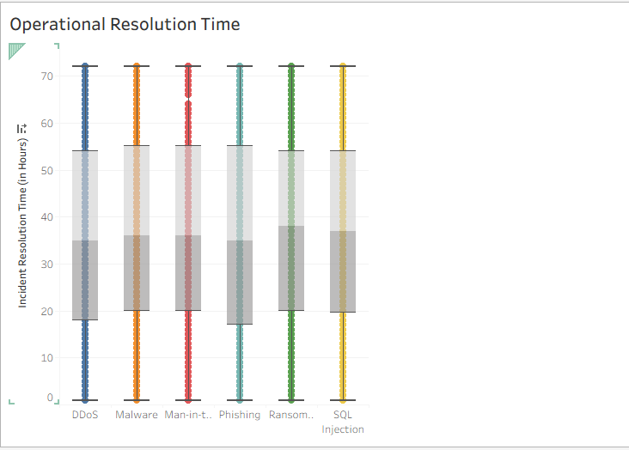

V. CONCLUSION AND RECOMMENDATIONS

The integrated database design and visualization project successfully provided clear, evidence-based insights for strategic cybersecurity prioritization.

Strategic Recommendations
Mitigation efforts should prioritize the following:
1. Focus on US Operations: Immediate allocation of resources and threat intelligence toward US-based infrastructure.
2. Harden Against Key Attacks: Implement advanced defenses against Ransomware and SQL Injection.
3. Protect Critical Services: Focus immediate hardening and disaster recovery planning on the Telecommunications and Banking service lines.

Project Limitations and Future Improvements
- Data Context: The current dataset lacks crucial contextual details, such as whether attacks resulted in data breaches.
- Normalization: Financial loss values are not normalized by industry size or GDP, limiting the precision of direct comparisons.
- Improvement: Future analysis should incorporate basic economic measures for relative exposure.

REFERENCES

| Source | Type | Citation |
| Data Source | Dataset | Kaggle "Global Cybersecurity Threats 2015–2024" Dataset. |
| Methodology | Normalization | Codd, E.F. (1970). "A Relational Model of Data for Large Shared Data Banks" (3NF Normalization). |
| Tools | Software | Microsoft SQL Server Documentation & SSMS User Guide; Tableau Software. |
| Industry Standards | Reference | NIST Cybersecurity Framework (Reference for Risk Scoring weights). |

